**Assessment Real World Recursion**

**Jeffrey Chiu 5/24/18**

**Pattern:**

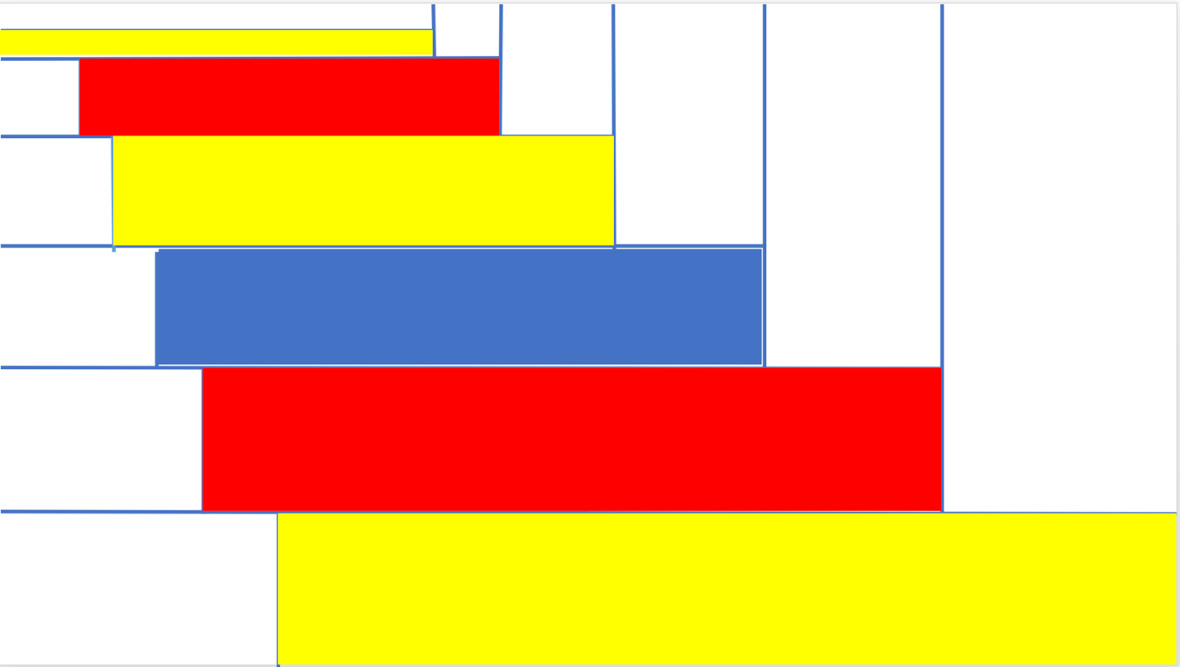

**Recursive Method**

In each recursion, block split into four rectangles will be drawn, with the bottom left one shaded with a random color.

draw(int n, int xlength, intylenth){/*Draws 3 box form according to dimensions given, recurses n times*/}

**Responses:**

1. The recursive image I created was based on a rectangular dilation of the original image by a factor of ¾. The base case featured 4 rectangles, with two of the smaller uncolored rectangles adding up to equal the area of the larger colored rectangle.
2. The recursion principle is the draw(int n, int xlength, int ylength) methbod shown above. This method takes a blank rectangle with dimensions xlength and ylength and creates the four rectangle form present in my pattern n times.
3. The programmer should receive the credit. The CPU and software are only mediums for the programmer to work on, the pattern itself is the programmer’s unique innovative idea.
4. Yes, any computer generating anything that is innovative and previously undiscovered can be attributed as artificial intelligence, however low-level it may be. Yet, the artificial intelligence program would be relatively primitive as it is easy to play around with multiples and create a pattern similar to mine.
5. Yes, currently the defining factor behind computer and human art is the emotional aspect and personality of each artwork given by the artist. If a computer were able to replicate the emotions behind an artwork, such as the Mondrian, that artwork would no longer be special and would diminish the accomplishments of humans